Expanding Hyndman’s idea to FAE:
The algorithm below is what we have in Hyndman’s paper:
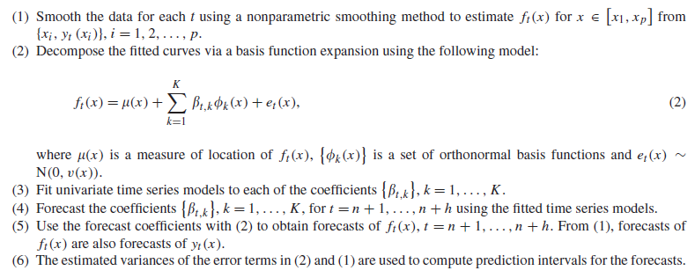
This algorithm takes the PCA coefficients and implements the time series and then continues the rest of analysis using the predicted coefficients. In FAE, we have rep in the latent space as our PC and the following architecture:
We can combine them very cleanly if you interpret your data the “Hyndman way”:
- At each calendar time t =1, …, n we observe one whole curve $X_{t}(.)$(e.g., a yearly mortality curve over age x).
- Our goal is to forecast future curves $X_{n+h}(.)$ by forecasting a low-dimensional coefficient vector.
Hyndman: smooth → basis/FPCA scores $β_{t,k}$→ time-series on ​ $β_{t,k}$→ reconstruct future curves.
FAE already does: curve → latent rep $h_{t}$→ coefficient layer $b_{t}$→ reconstruct curve $\hat{X_{t}}(.) = \sum_{m}{b_{t,m} ϕ_{m}^{(O)}(.)}$.
So, we can put time series in FAE on $b_{t}$ or on $h_{t}.$
ARIMA on the FAE coefficient layer $b_{t}$
In the 2024 FAE, the coefficient layer neurons $b_{m}$​ are literally basis coefficients for the reconstructed function.
- Train the FAE as usual to reconstruct each curve (no TS yet). This gives you a coefficient vector $b_{t} ∈ R^{M(O)}$for each time t.
- For each coefficient dimension m, fit a univariate time-series model to {$b_{1,m},..., b_{n,m}$} (ARIMA, Hyndman).
  - If $ϕ_{m}^{(O)}$are orthonormal (or you orthogonalize/whiten the coefficient vectors), we’re closer to Hyndman’s “coefficients are (approximately) uncorrelated so univariate forecasting is adequate.”
  - If not, use VAR (or a shrinkage VAR) on $b_{t}$ instead of separate ARIMAs.
- Forecast ${\tilde{b}}_{n+h}$. Then reconstruct the future curve using the existing deterministic decoder basis layer:
${\hat{X}}_{n+h}(t) =\sum_{m=1}^{M(O)}{{\tilde{b}}_{n+h}ϕ_{m}^{(O)}(t)}$.
This mirrors Hyndman’s “forecast coefficients + basis expansion = forecast curve”. We don’t touch the FAE architecture; we just “bolt on” Hyndman forecasting. The decoder already gives us a principled reconstruction map from coefficients to curves.

Add a temporal module that predicts $b_{t+1}$ inside the network
We can still use Hyndman’s idea (TS on coefficients), but you learn the TS model jointly by Inserting a temporal block on top of the coefficient vectors: $b_{t} = FAE(X_{t}) →{\tilde{b}}_{t+1} = {TS}_{ψ}(b_{t-L+1:t}),$where ${TS}_{ψ}$ can be linear AR / VAR layer or GRU/LSTM. Then decode ${\tilde{b}}_{t+1}$ to a function using the same basis layer.
- Reconstruction Loss: ${\left\|X_{t} - {\hat{X}}_{t}\right\|}^{2}$
- Forecasting: ${\left\|X_{t+1} - {{\hat{X}}_{t+1}}^{pred}\right\|}^{2}$ where ${{\hat{X}}_{t+1}}^{pred} = \sum_{m}{{\tilde{b}}_{t+1}ϕ_{m}^{(O)}}$.
This gives us “FAE smoothing + learned coefficient dynamics” in one model.

Time series on the latent representation $h_{t}$, then map to coefficients
Instead of forecasting $b_{t}$ directly, forecast the representation layer $h_{t}$ (bottleneck). In the 2024 diagram, ℎ is explicitly the “Hidden layer (Representation)”.
- Encoder: $X_{t}$ → latent rep $h_{t}$
- Temporal model: $h_{t-L+1:t}$ → ${\tilde{h}}_{t+1}$
- Decoder head:${\tilde{h}}_{t+1}$→ ${\tilde{b}}_{t+1}$ → ${\hat{X}}_{t+1}$
We can use it when we want the temporal model to act on a more compact, more “semantic” state than the basis coefficient vector. Or If 𝑀(𝑂) is large (many basis functions) but ℎ is small.

